**LAB TASK 01**

**MOHAMMAD BASIL ALI KHAN**

**20K-0477**

**Task#01:**

* **Code**

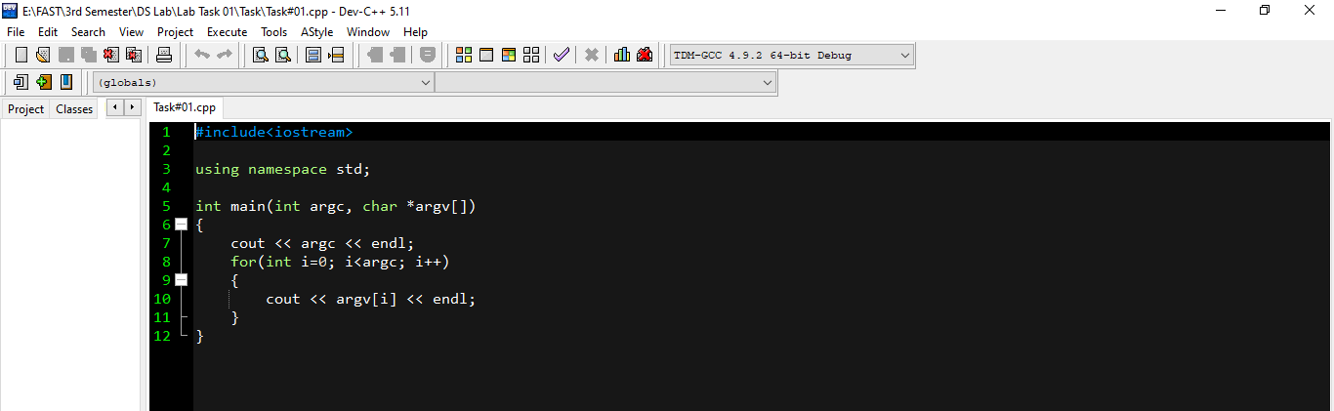

* **Command Line argument**

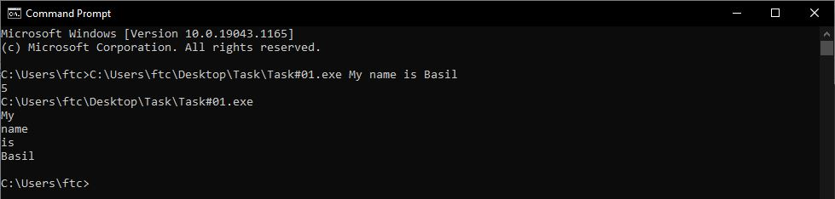

**Task#02:**

* **Code**

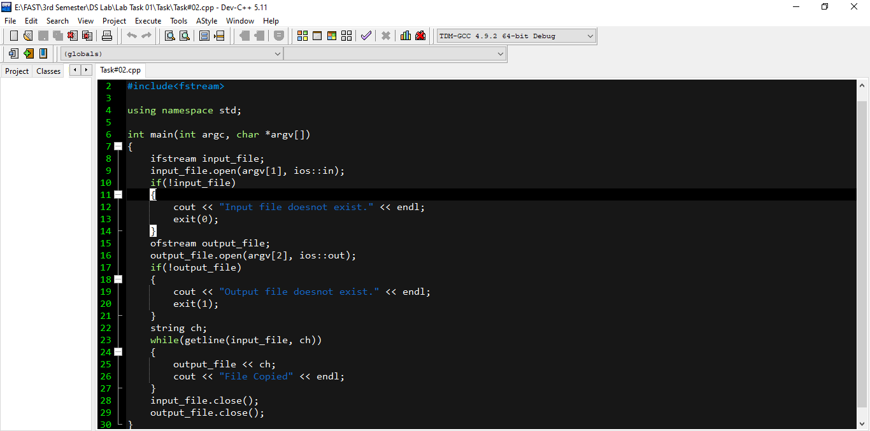

* **Command Line argument**

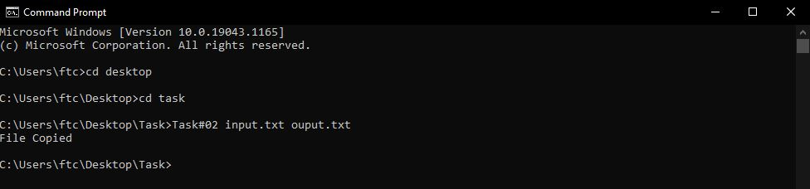

* **Input file**

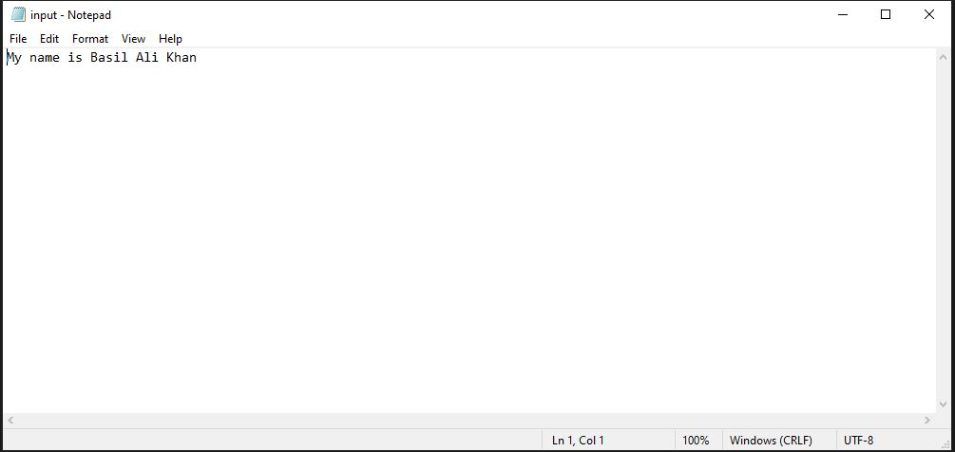

* **Output file**

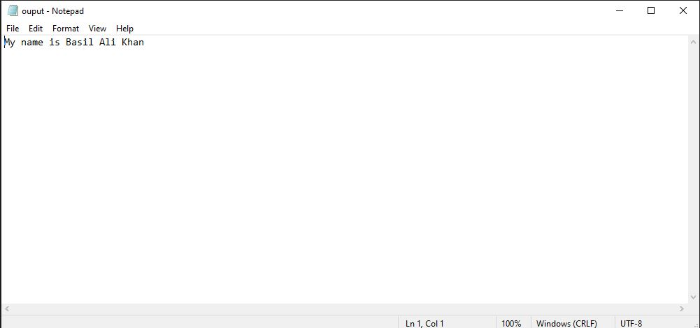

**Task#03:**

* **Code**

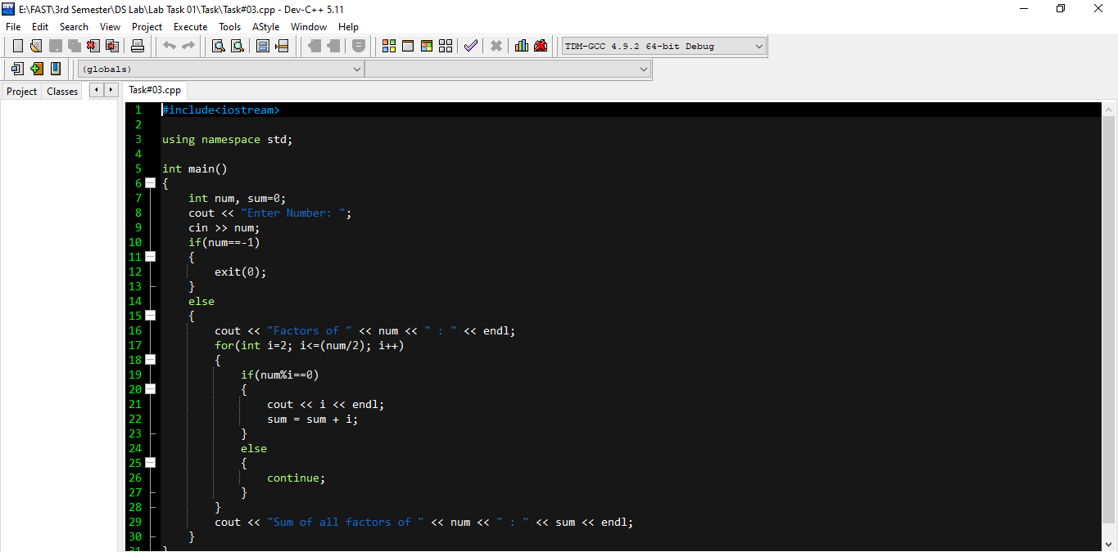

* **Debugging**
* **If value other than -1 is given as input:**

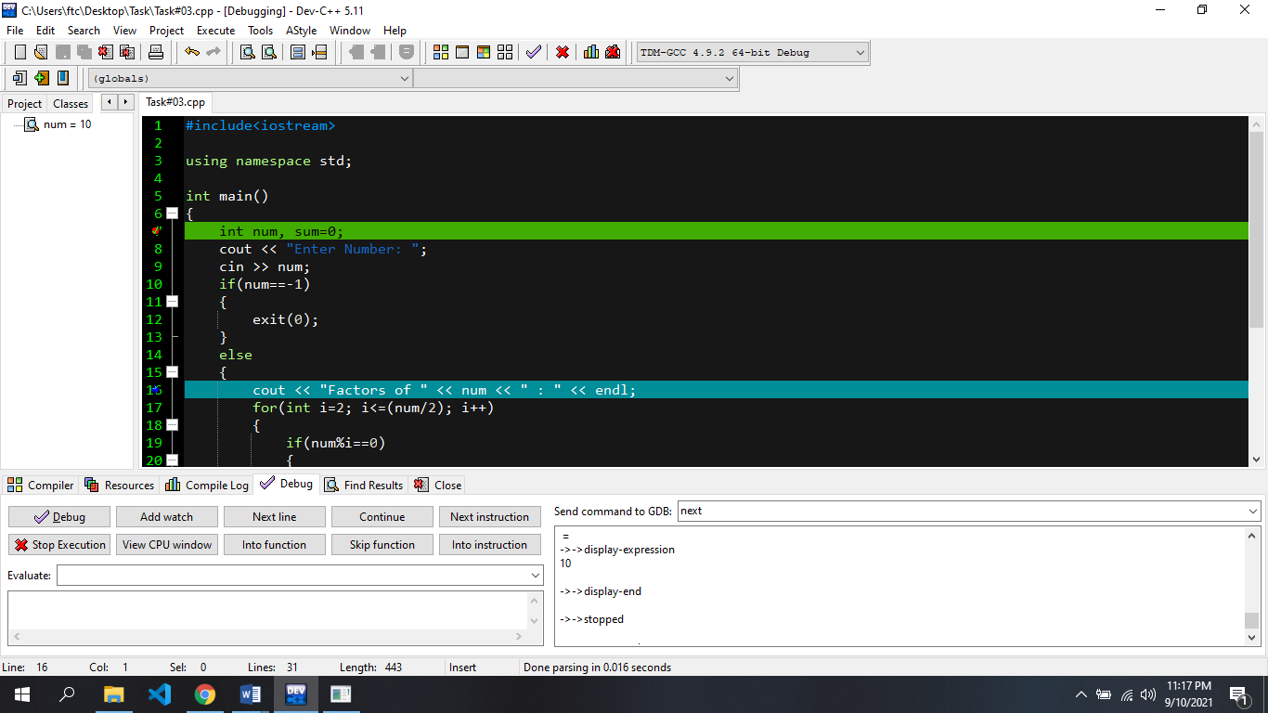

* **If value -1 is given as input:**

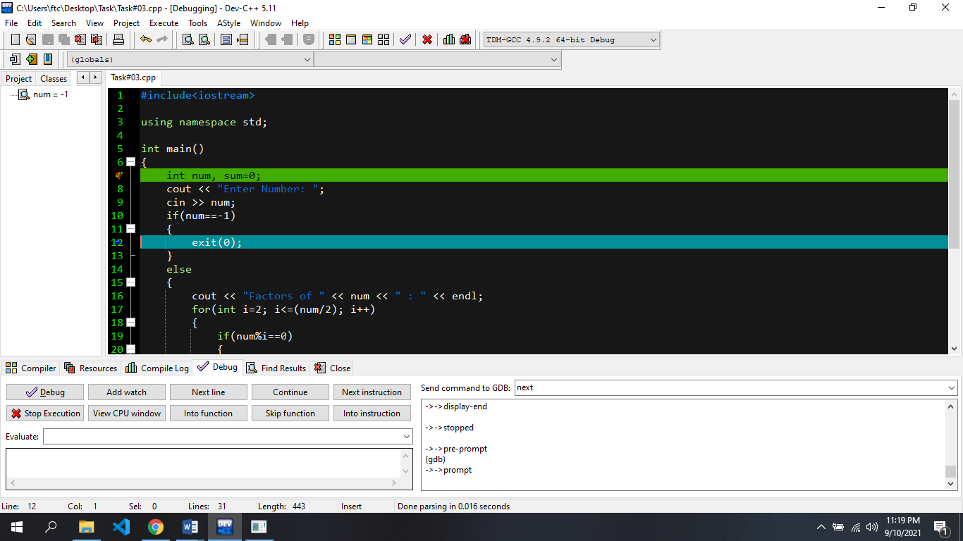

* **Output**

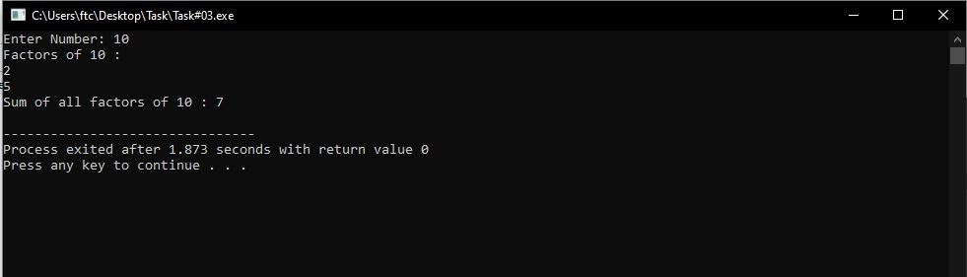

**Task#04:**

* **Code**

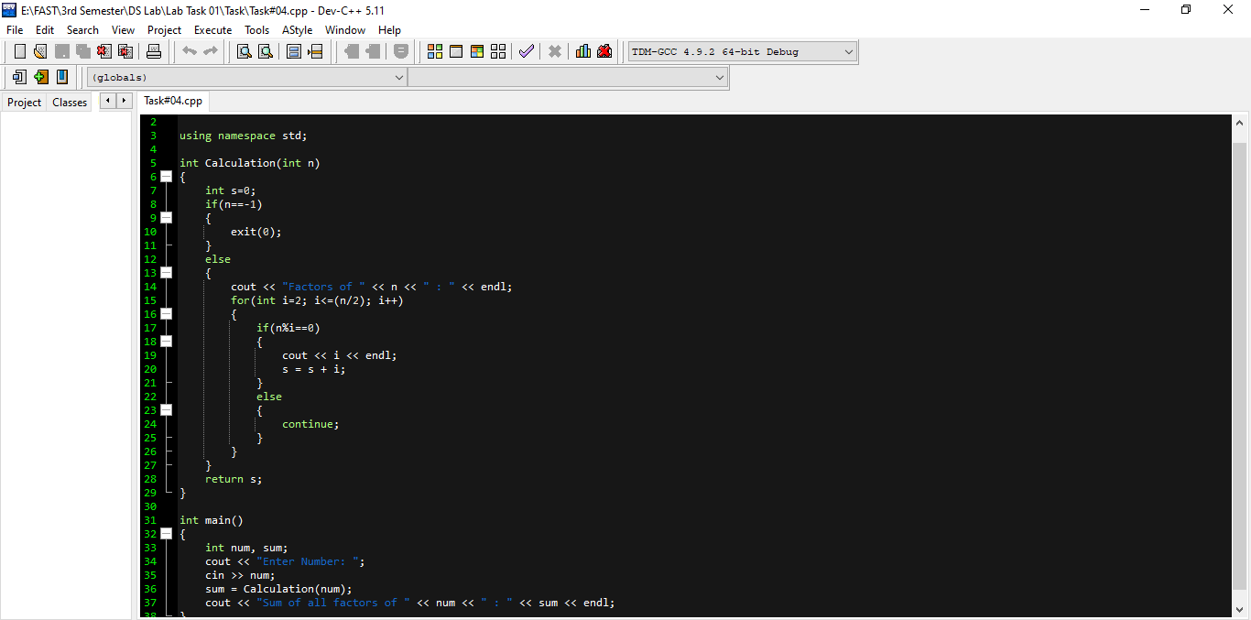

* **Debugging**

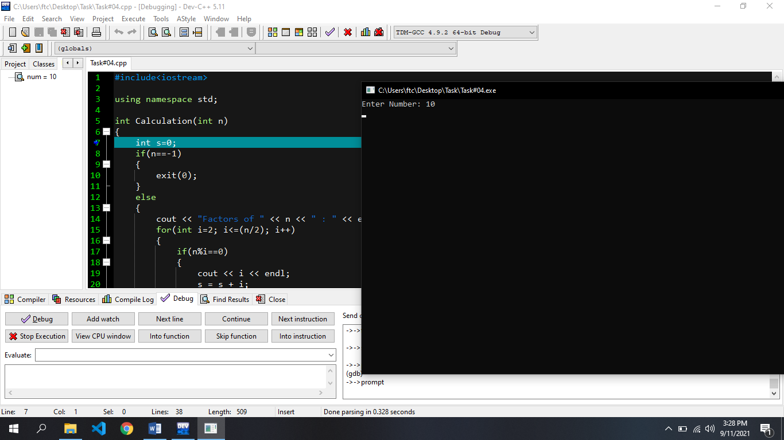

**Task#05:**

* **Code**

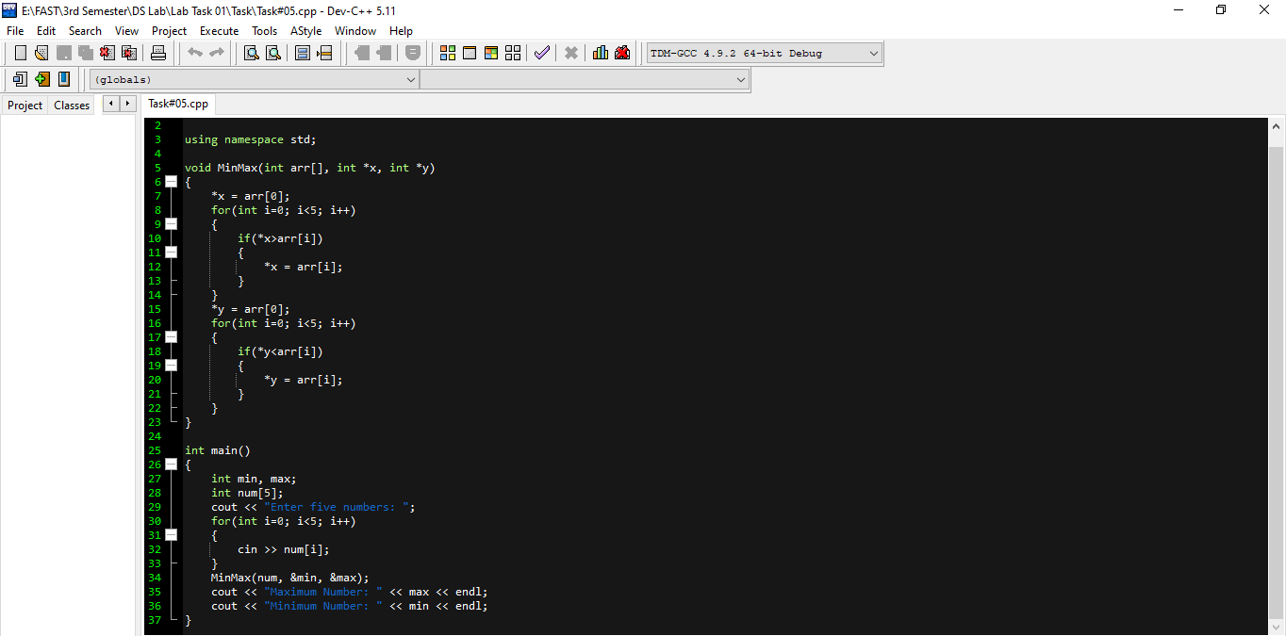

* **Output**

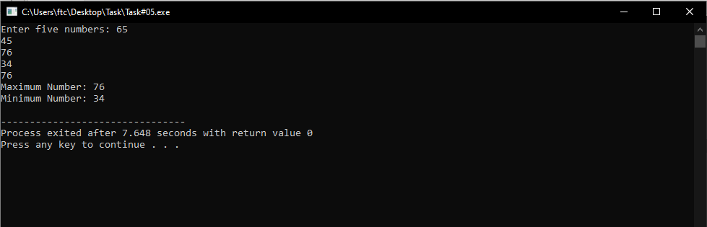

**Task#06:**

* **Code**

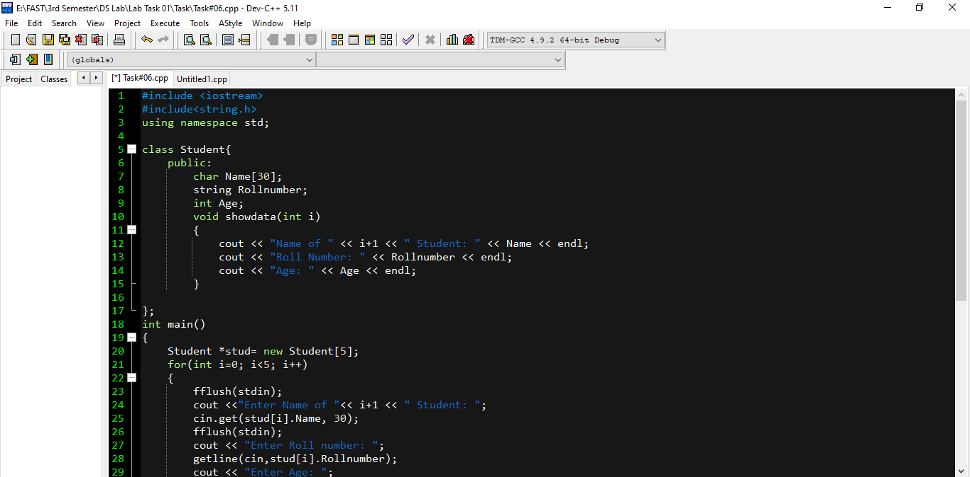

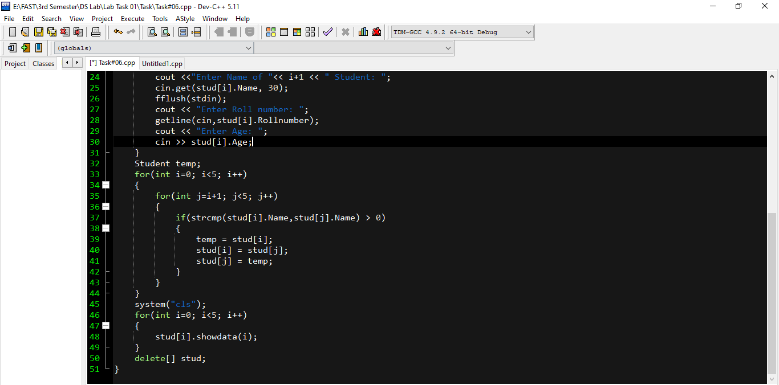

* **Input**

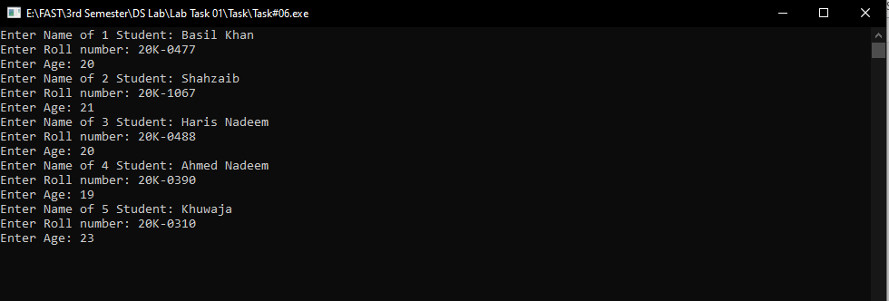

* **Output**

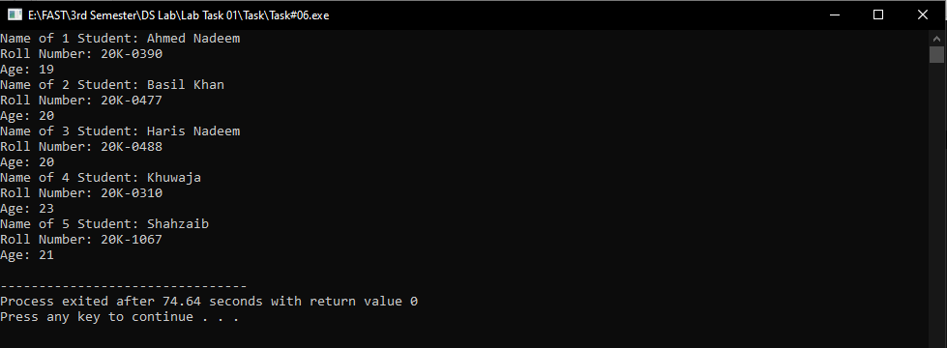

**Task#07:**

* **Code**

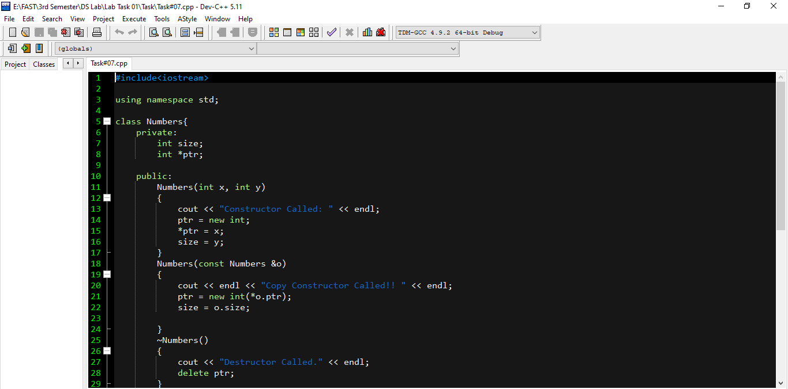

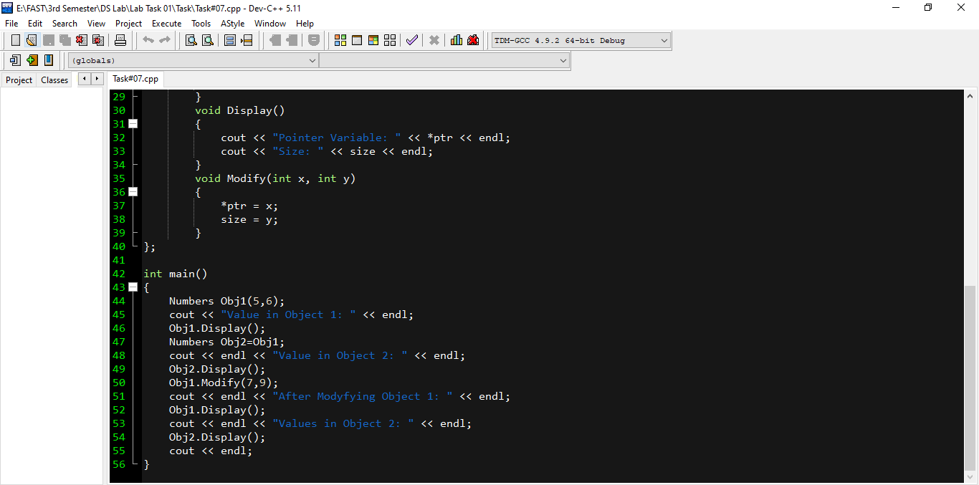

* **Output**

